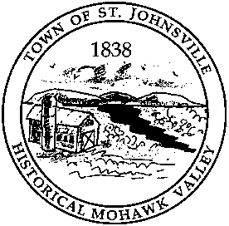
Town of St. Johnsville
PO Box 28 - 7431 STHWY 5 - St. Johnsville, NY 13452
Telephone: (518) 568-2662 ext. 302 FAX (518) 568-7811
E-Mail: selwoodcodes@gmail.com

Office of The Code Enforcement Officer/Land Use Enforcement Officer

PERMIT FEE SCHEDULE

New Home or Structure Built on Site $ 150.00
Modular Home/Mobile Home (Single/Double Wide) $ 75.00
Garage (One, Two & Three Stall) (24’X36’ max. size) $ 50.00
Garage (larger than 24’X36’) $ 75.00
Commercial Building (maximum charge $2,000) $ 00.15/sq. ft.
Additions to Existing Structures & $ 25.00
Remodeling, etc. (if required)
Septic Systems $ 50.00
Perk Testing (if required) $ 100.00
Solid Fuel, Heating Systems & Chimneys $ 25.00
Swimming Pools (Above & In ground) $ 25.00
Garage & Yard Sales (7 days, limit 2/yr.) $ N/C
Certificate of Occupancy (with permit) N/C
Certificates of Occupancy (without permit) $ 25.00
Agricultural (Permit Required) N/C
Demolition Permit N/C
Sheds (under 10’X12’) N/C
Sheds (over 10’X12’) $ 10.00
Vendor Permit Required N/C
Failure to Remove Trash After Ticketed $ 100.00

*All permits are good for one year (Permit Renewals) $ 10.00

Steven Elwood
Code Enforcement Officer/
Land Use Enforcement Officer

