Town of St. Johnsville
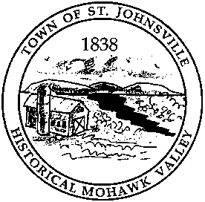
PO Box 28 - 7431 STHWY 5 - St. Johnsville, NY 13452
Telephone: (518) 568-2662 FAX (518) 568-7811

LEGAL NOTICE

The Town of St. Johnsville will hold public hearings/meeting on three proposed Local Laws. Local Law No. 1 of 2025 “A Local Law Regulating the Placement & Usage of Recreational Vehicles and Recreational Dwellings within the Town of St. Johnsville, Local Law #2 of 2025 “Code of Ethics” & Local Law # 3 “A Local Law Opting Out of the Exception Provided by Real Property Tax Law Section 487” on March 31, 2025, at 6:45 pm.

Any person in favor of or against the proposed laws will be heard. Copies of the proposed Local Laws are available at the Town Clerk’s office during regular business hours.

Lynn M. Stever
Town Clerk

