Town of St. Johnsville
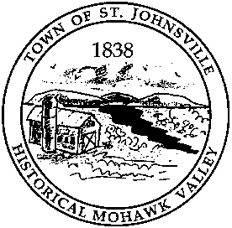
PO Box 28 - 7431 STHWY 5 - St. Johnsville, NY 13452
Telephone: (518) 568-2662 FAX (518) 568-7811

Office of the Town Clerk

Legal Notice

The Town of St. Johnsville will hold a public hearing on June 10, 2025, at 6:35pm at the Town Offices, 7431 STHWY 5, St. Johnsville, NY, on proposed Local Law No. 5 of 2025 "A Local Law to Amend the Land Use Law for the Further Regulation of Quarries and to Repeal Local Law No. 2 of 2024”.

Any person in favor of, or against said law, will be heard. "A copy of the proposed law is available for review at the office of the Town Clerk during regular business hours."

By Order of the Town Board
Town of St. Johnsville
Lynn M. Stever, Town Clerk
Dated: May 15, 2025

