Town of St. Johnsville
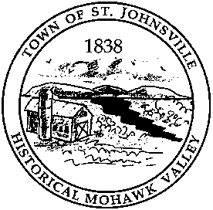
PO Box 28 - 7431 STHWY 5 - St. Johnsville, NY 13452
Telephone: (518) 568-2662 FAX (518) 568-7811

AGENDA

March 31, 2025

** Public Hearing on proposed Local Law #1, #2 & #3 at 6:45 pm**

Special Meeting to follow Public Hearings

- Call to Order
- Salute to the flag
- Roll Call
- Public Comment
- Proposed Local Law #1 (RV)
- Proposed Local Law #2 (Code of Ethics)
- Proposed Local Law #3 (Opt Out of Solar PILOTS)
- Other
- Public Comment
- Adjournment

