Town of St. Johnsville
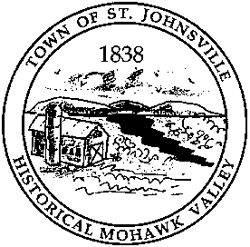
PO Box 28 - 7431 STHWY 5 - St. Johnsville, NY 13452
Telephone: (518) 568-2662 FAX (518) 568-7811

Office of the Town Clerk

Legal Notice

The Town of St. Johnsville will hold a public hearing on June 10, 2025, at 6:30pm at the Town Offices, 7431 STHWY 5, St. Johnsville, NY, on proposed Local Law No. 4 of 2025 "A Local Law to Repeal and Amend Various Provisions of the Town of St. Johnsville Land Use Law”.

Any person in favor of, or against said law, will be heard. "A copy of the proposed law is available for review at the office of the Town Clerk during regular business hours."

By Order of the Town Board
Town of St. Johnsville
Lynn M. Stever, Town Clerk
Dated: May 15, 2025

